ARTIFICIAL INTELLIGENCE LABORATORY
Lab Record – Programs 1 to 33

PROGRAM 1: Write a Python program to solve the 8-Puzzle problem
AIM: To solve the 8-Puzzle problem by finding a sequence of moves that transforms the initial board into the goal board.
PROCEDURE:
- Represent the puzzle as a 3×3 board with one blank space.
- Define the possible moves of the blank space.
- Apply a search method to explore valid states and avoid revisiting states.
- Stop when the goal arrangement is reached and display the solution path.
INPUT:
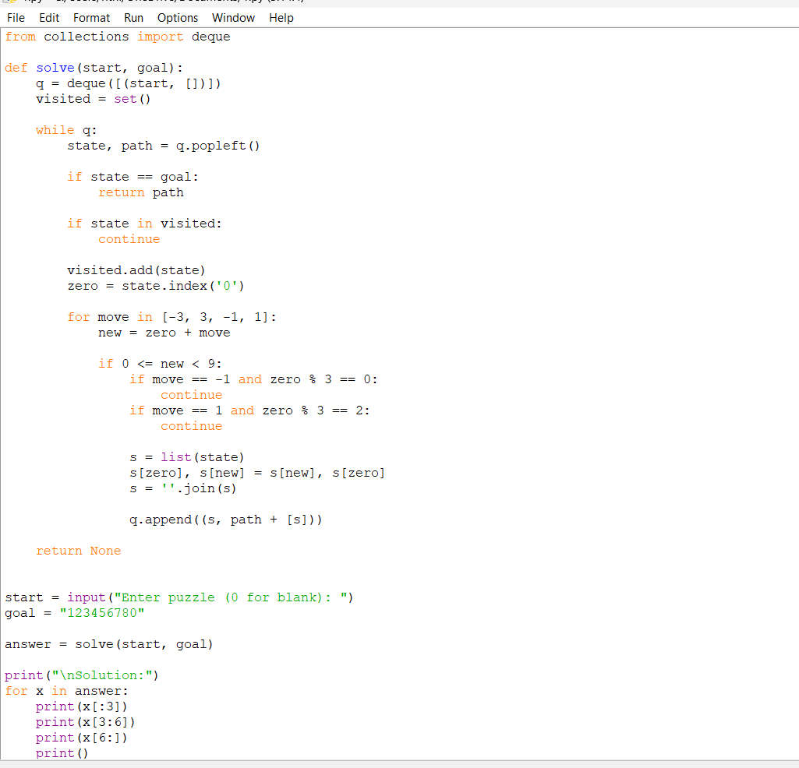
OUTPUT:
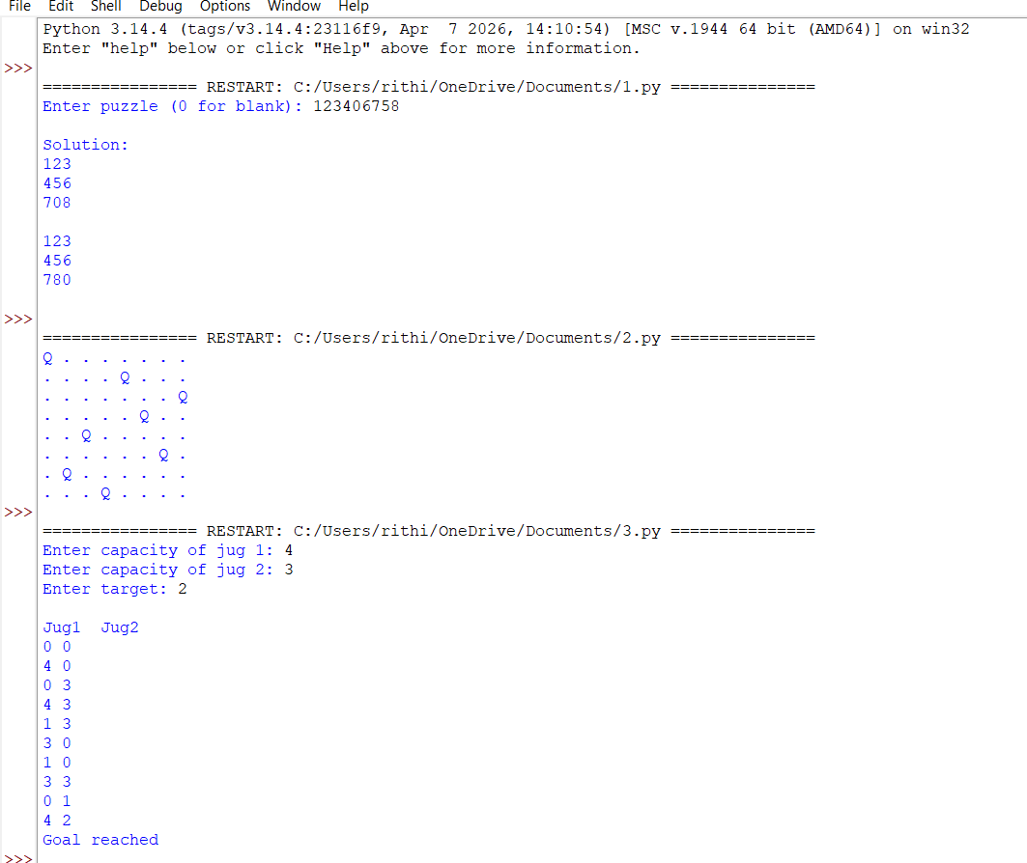

RESULT: Thus, the above program was implemented and the expected result was obtained.

PROGRAM 2: Write a Python program to solve the 8-Queen problem
AIM: To place eight queens on an 8×8 chessboard so that no two queens attack each other.
PROCEDURE:
- Start with an empty chessboard.
- Place one queen in each row.
- Before placing a queen, check its column and both diagonals for conflicts.
- If a position is unsafe, try another column; backtrack when no position is possible.
- Display the completed board when all eight queens are placed.
INPUT:
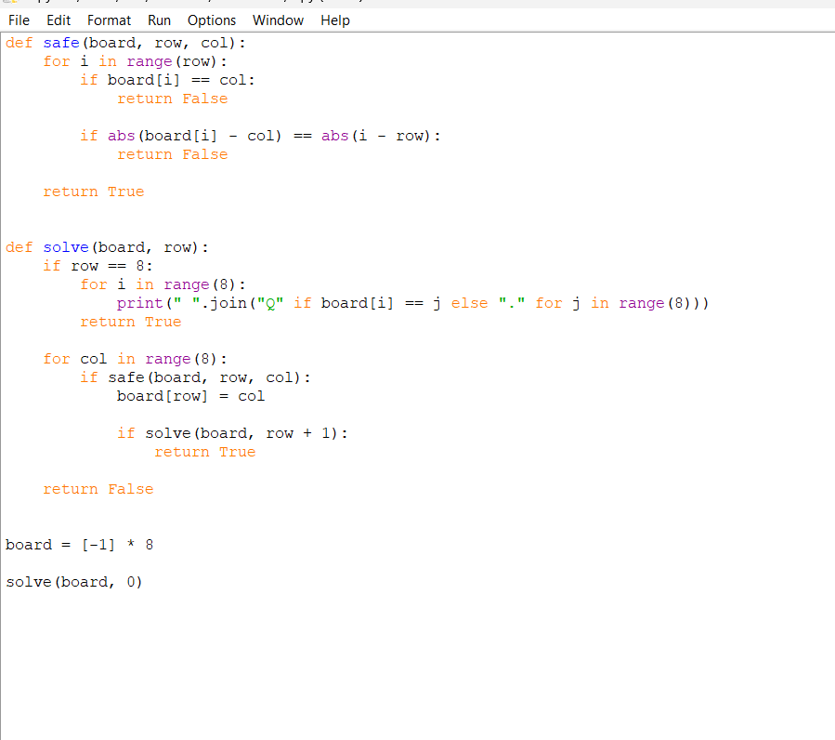
OUTPUT:
RESULT: Thus, the above program was implemented and the expected result was obtained.

PROGRAM 3: Write a Python program for the Water Jug problem
AIM: To obtain a required quantity of water using two jugs of fixed capacities.
PROCEDURE:
- Specify the capacities of both jugs and the target quantity.
- Represent each state by the amount of water in each jug.
- Generate states using fill, empty and pour operations.
- Use search with a visited-state check to find a path to the target.
- Display the sequence of operations.
INPUT:
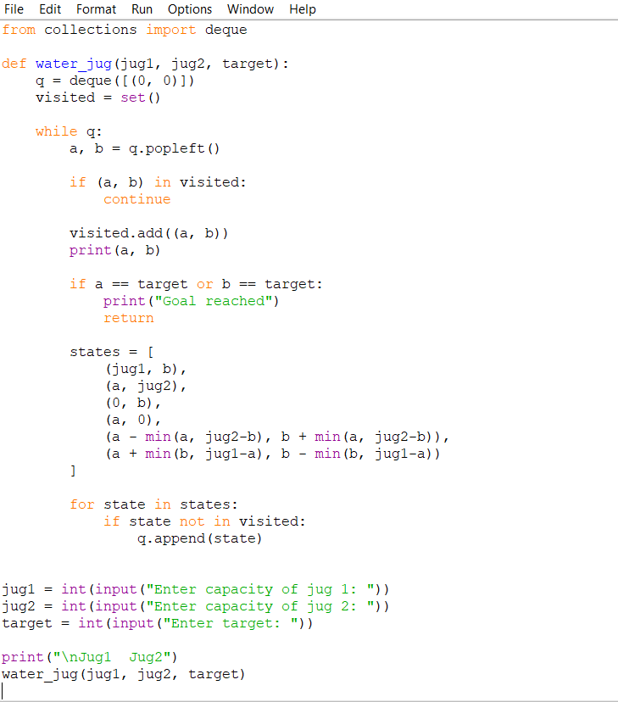
OUTPUT:
RESULT: Thus, the above program was implemented and the expected result was obtained.

PROGRAM 4: Write a Python program for the Crypt-Arithmetic problem
AIM: To assign digits to letters in an arithmetic puzzle so that the given equation is mathematically correct.
PROCEDURE:
- Read the arithmetic equation.
- Identify the distinct letters and assign different digits to them.
- Do not allow a leading letter to have the value zero.
- Check the equation for each valid assignment.
- Display the assignment that satisfies the equation.
INPUT:
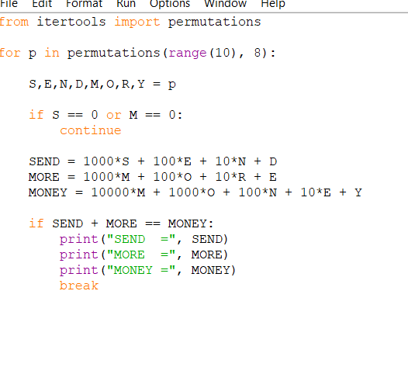
OUTPUT: 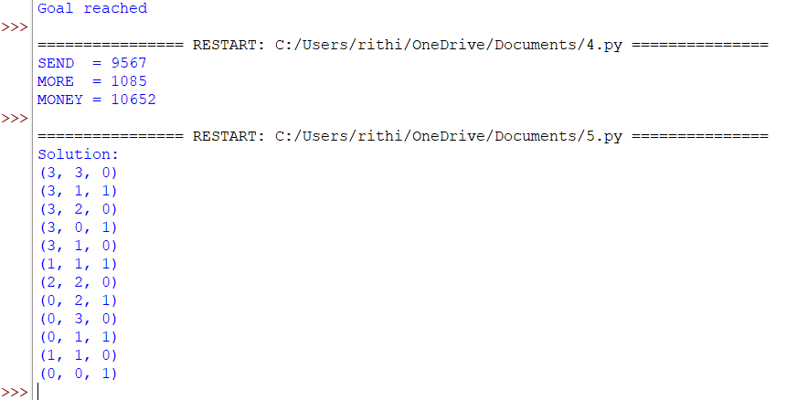
RESULT: Thus, the above program was implemented and the expected result was obtained.

PROGRAM 5: Write a Python program for the Missionaries and Cannibals problem
AIM: To move all missionaries and cannibals across a river without allowing cannibals to outnumber missionaries on either bank when missionaries are present.
PROCEDURE:
- Represent the number of missionaries and cannibals on each bank and the boat position.
- Generate legal boat moves carrying one or two people.
- Reject states that violate the safety condition.
- Use search and avoid revisiting states.
- Print the sequence of safe crossings.
INPUT:
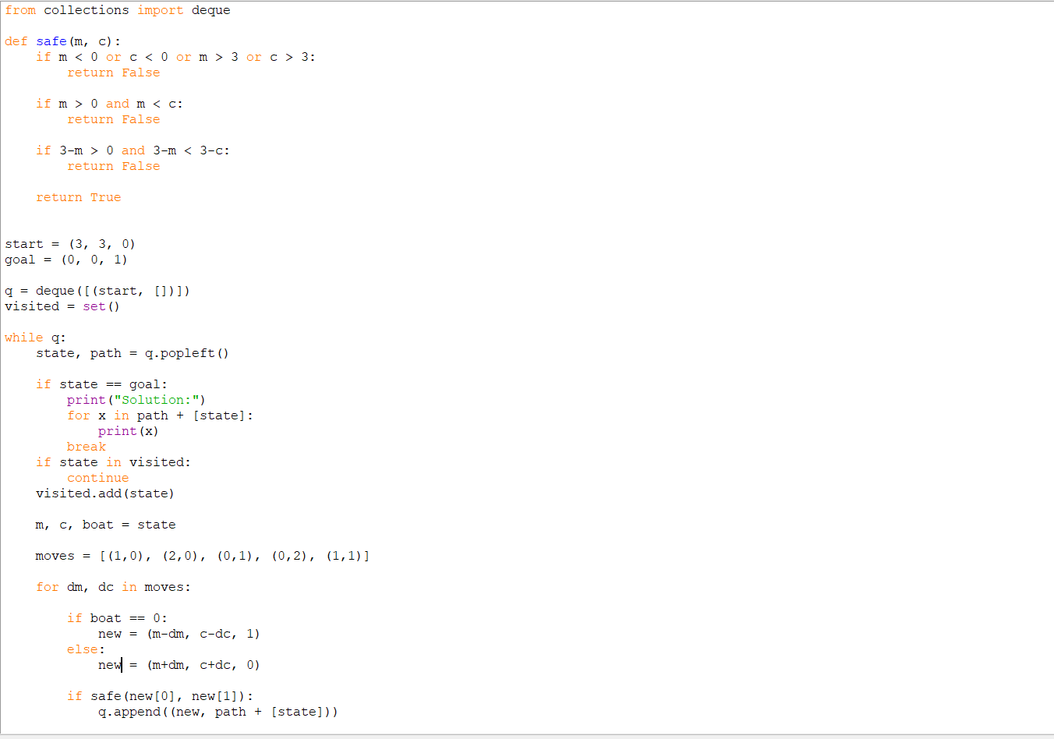
OUTPUT:
RESULT: Thus, the above program was implemented and the expected result was obtained.

PROGRAM 6: Write a Python program for the Vacuum Cleaner problem
AIM: To model a vacuum cleaner agent that cleans dirty rooms in an environment.
PROCEDURE:
- Represent each room and its condition as clean or dirty.
- Set the initial location of the vacuum cleaner.
- Check the current room condition.
- Clean the room if it is dirty and move to the next room when required.
- Display the actions and final room conditions.
INPUT:
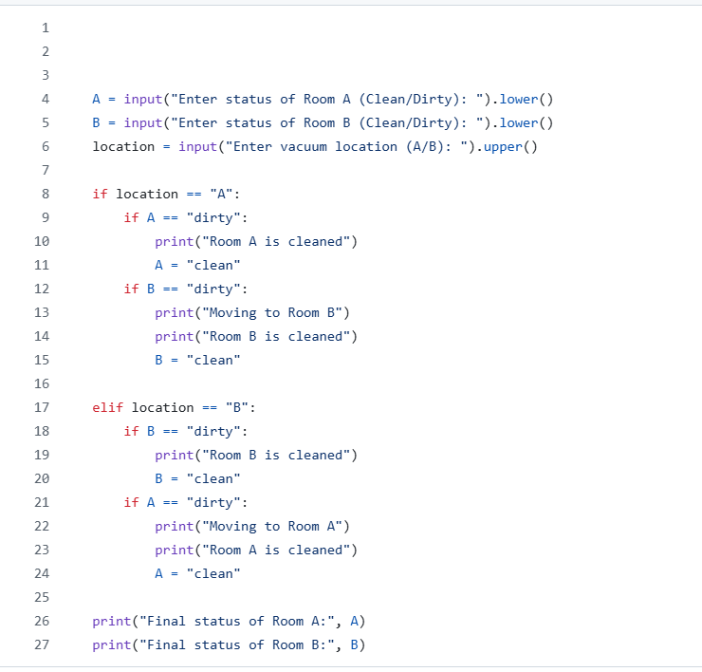
OUTPUT:
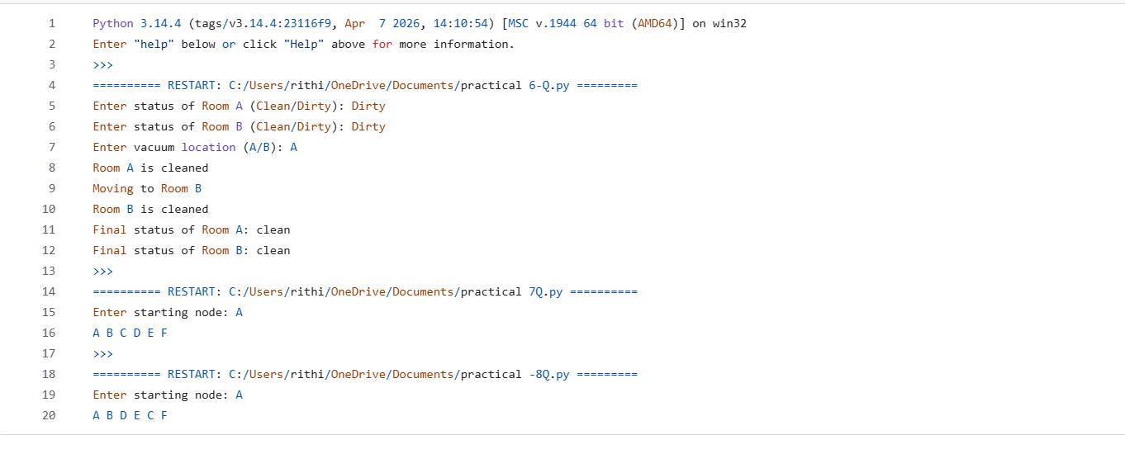
RESULT: Thus, the above program was implemented and the expected result was obtained.

PROGRAM 7: Write a Python program to implement BFS
AIM: To traverse a graph using Breadth First Search.
PROCEDURE:
- Represent the graph using an adjacency list or matrix.
- Choose the starting vertex and mark it as visited.
- Insert the starting vertex into a queue.
- Remove a vertex from the queue, display it and enqueue its unvisited neighbours.
- Continue until the queue becomes empty.
INPUT:
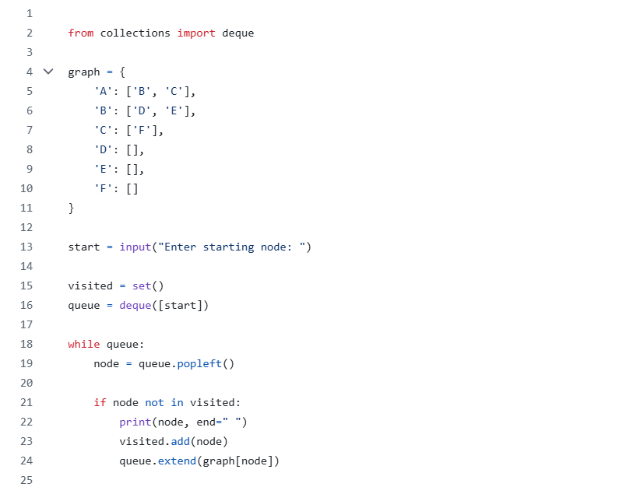
OUTPUT:

RESULT: Thus, the above program was implemented and the expected result was obtained.

PROGRAM 8: Write a Python program to implement DFS
AIM: To traverse a graph using Depth First Search.
PROCEDURE:
- Represent the graph using an adjacency list or matrix.
- Choose a starting vertex and mark it as visited.
- Visit an unvisited adjacent vertex recursively or by using a stack.
- Continue exploring deeper vertices before backtracking.
- Stop when all reachable vertices are visited.
INPUT:
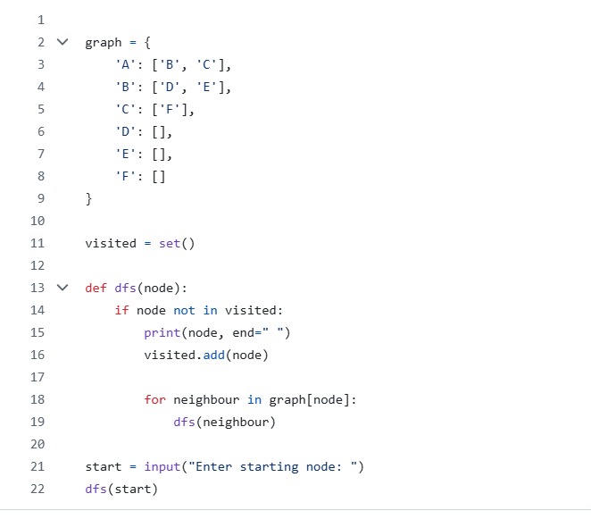
OUTPUT:

RESULT: Thus, the above program was implemented and the expected result was obtained.

PROGRAM 9: Write a Python program to implement the Travelling Salesman Problem
AIM: To find a minimum-cost tour that visits every city exactly once and returns to the starting city.
PROCEDURE:
- Read the number of cities and the distance or cost matrix.
- Generate possible city visiting orders, fixing one city as the start.
- Calculate the total cost of each complete tour, including the return to the start.
- Select the tour with the least total cost.
- Display the best tour and its cost.
INPUT:
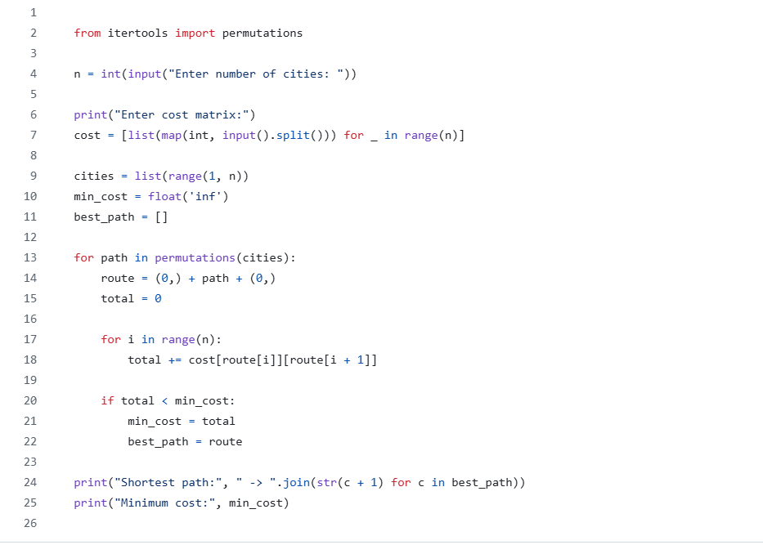
OUTPUT:
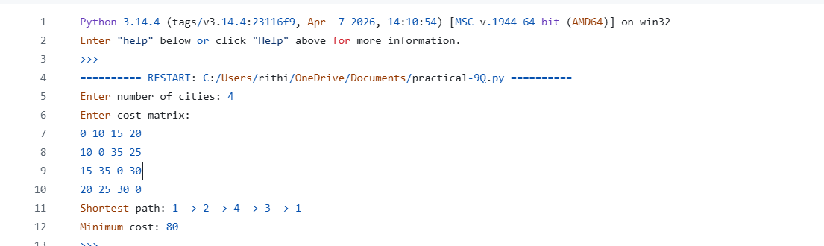
RESULT: Thus, the above program was implemented and the expected result was obtained.

PROGRAM 10: Write a Python program to implement the A* algorithm
AIM: To find a path from a start node to a goal node using path cost and a heuristic estimate.
PROCEDURE:
- Represent the graph with edge costs and define a heuristic for each node.
- Initialize the start node with path cost zero.
- Select the open node with the smallest f(n)=g(n)+h(n).
- Update the costs and parent of each neighbour when a better path is found.
- Continue until the goal is selected and reconstruct the path.
INPUT:
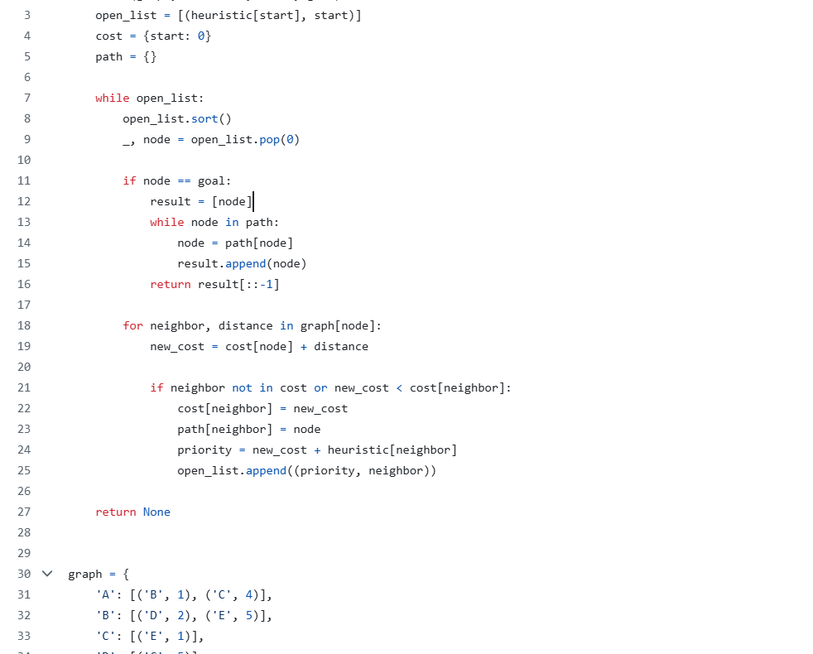
OUTPUT:
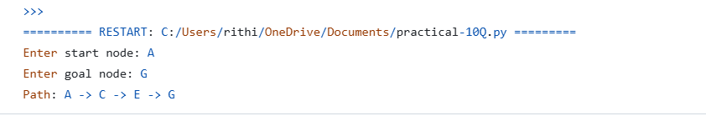
RESULT: Thus, the above program was implemented and the expected result was obtained.

PROGRAM 11: Write a Python program for Map Coloring to implement CSP
AIM: To color the regions of a map so that adjacent regions have different colors using a Constraint Satisfaction Problem.
PROCEDURE:
- Represent each region as a variable and list its neighbouring regions.
- Define the available colors as the domain of each variable.
- Assign a color to one region at a time.
- Check that the assigned color differs from the colors of all adjacent assigned regions.
- Backtrack if a conflict occurs and display a valid assignment.
INPUT:
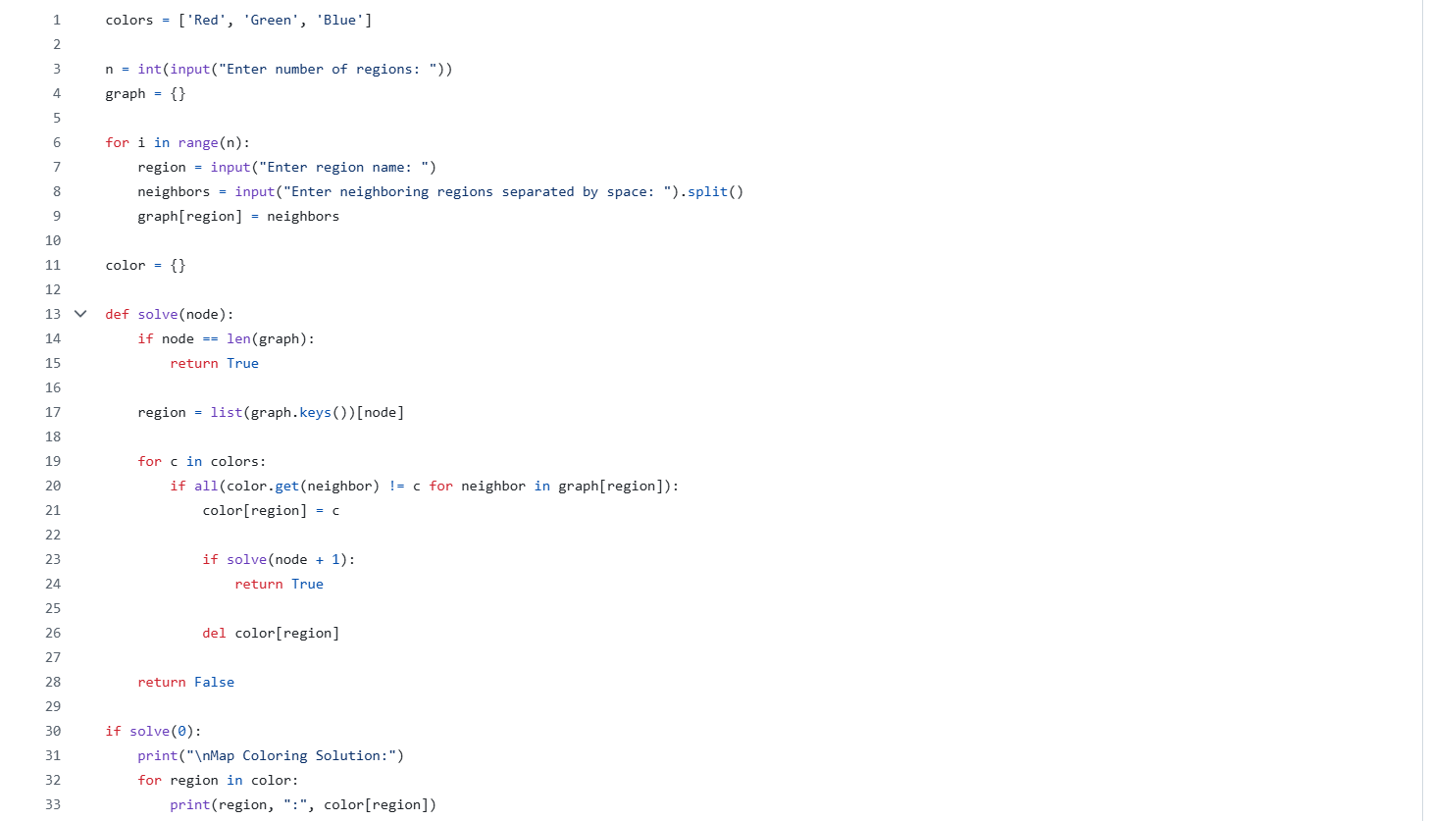
OUTPUT:
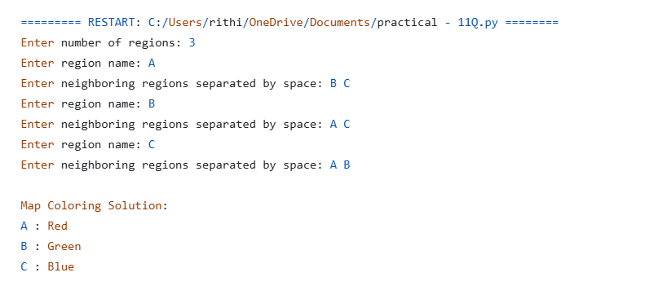
RESULT: Thus, the above program was implemented and the expected result was obtained.

PROGRAM 12: Write a Python program for Tic Tac Toe game
AIM: To develop a two-player Tic Tac Toe game on a 3×3 board.
PROCEDURE:
- Create an empty 3×3 board.
- Allow the players to enter their moves in turn.
- Check that each move is within the board and the selected cell is empty.
- After each move, check rows, columns and diagonals for a win.
- Declare a winner or a draw when the board is full.
INPUT:
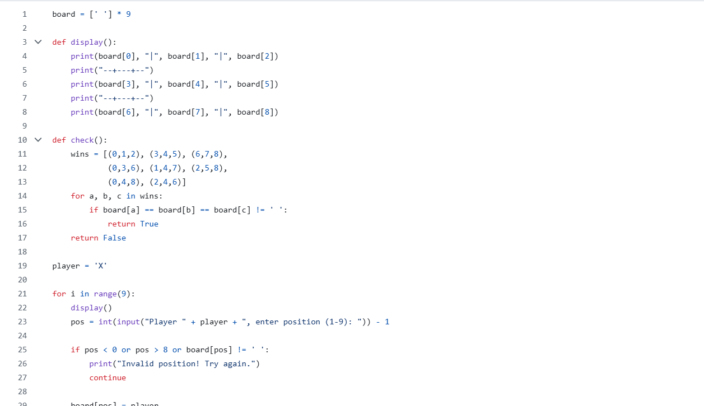
OUTPUT:
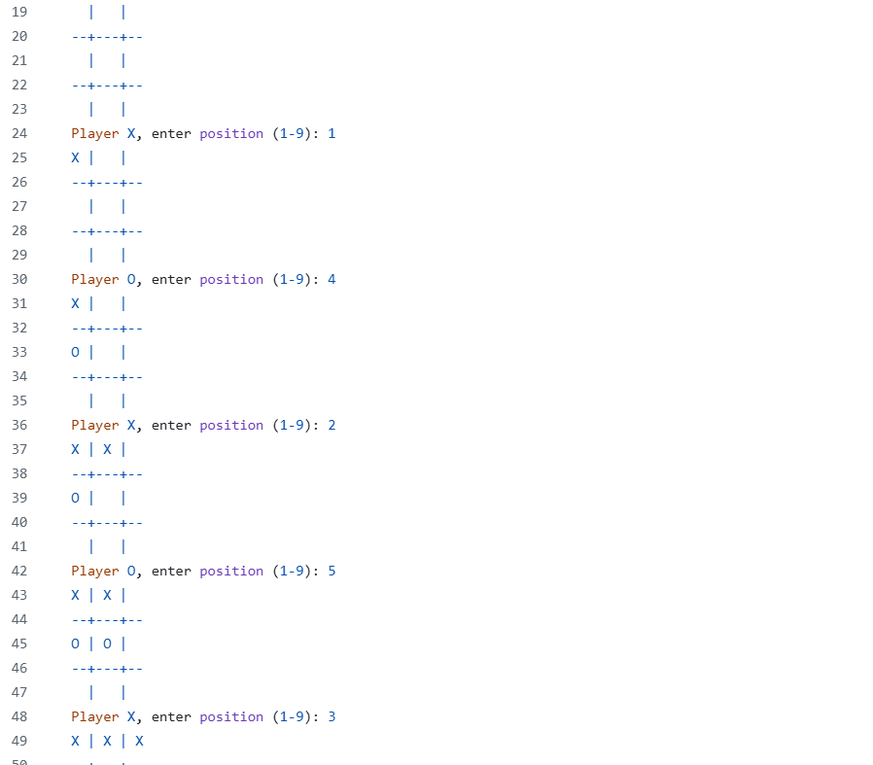
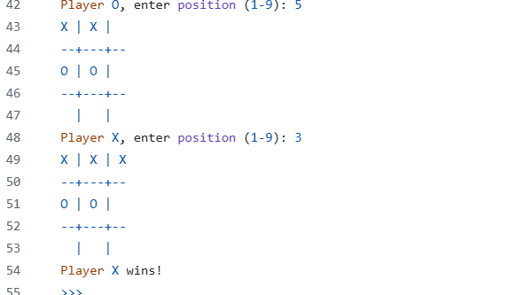
RESULT: Thus, the above program was implemented and the expected result was obtained.

PROGRAM 13: Write a Python program to implement the Minimax algorithm for gaming
AIM: To select the best move in a two-player game using the Minimax decision algorithm.
PROCEDURE:
- Represent the game states and legal moves.
- Define terminal-state utility values and, if needed, a depth limit.
- Recursively evaluate successor states.
- Choose the maximum value at the maximizing player's turn and the minimum at the minimizing player's turn.
- Select and display the move with the best Minimax value.
INPUT:
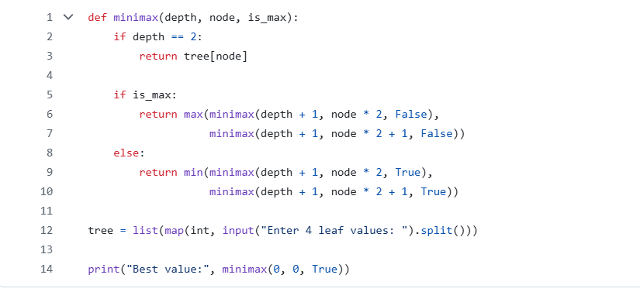
OUTPUT:
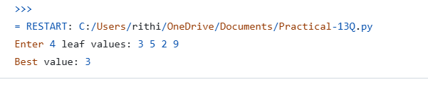
RESULT: Thus, the above program was implemented and the expected result was obtained.

PROGRAM 14: Write a Python program to implement Alpha-Beta Pruning algorithm for gaming
AIM: To optimize Minimax search by pruning branches that cannot affect the final decision.
PROCEDURE:
- Represent the game tree and assign evaluation values to terminal states.
- Initialize alpha to negative infinity and beta to positive infinity.
- At maximizing nodes, update alpha; at minimizing nodes, update beta.
- Stop exploring a branch when alpha is greater than or equal to beta.
- Display the best move and evaluation.
INPUT:
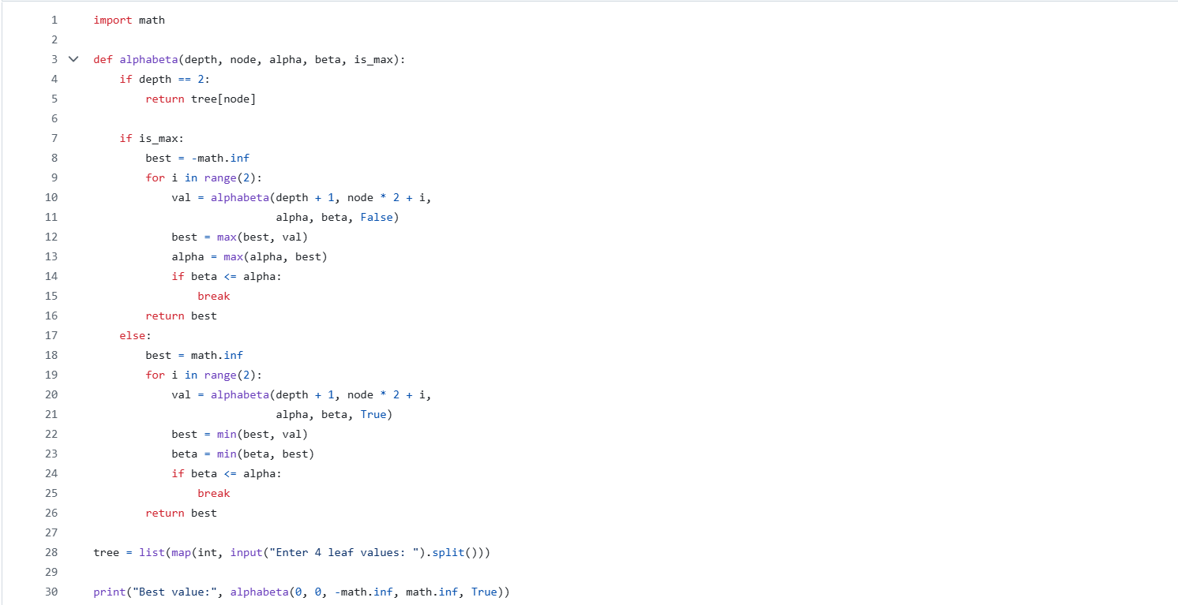
OUTPUT: 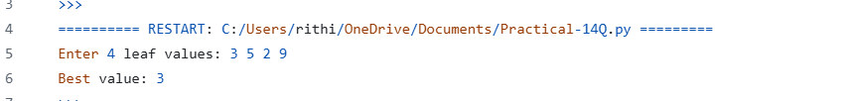
RESULT: Thus, the above program was implemented and the expected result was obtained.

PROGRAM 15: Write a Python program to implement Decision Tree
AIM: To build a decision-tree model that classifies data based on input features.
PROCEDURE:
- Prepare a labelled dataset and separate input features from target labels.
- Split the data into training and testing sets.
- Create and train a decision-tree classifier using a suitable criterion.
- Predict the labels for test data.
- Display predictions and, if required, model accuracy or the tree.
INPUT:
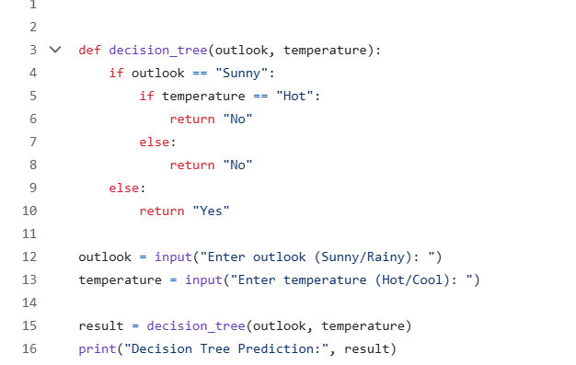
OUTPUT: 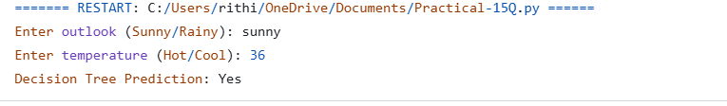
RESULT: Thus, the above program was implemented and the expected result was obtained.

PROGRAM 16: Write a Python program to implement Feed Forward Neural Network
AIM: To implement a feed-forward neural network that processes input data through successive layers to produce an output.
PROCEDURE:
- Prepare the input data and target values.
- Define the input, hidden and output layers with suitable activation functions.
- Initialize weights and biases.
- Pass input values forward through the network and calculate the output.
- Train the network by updating weights and display the predicted output.
INPUT:
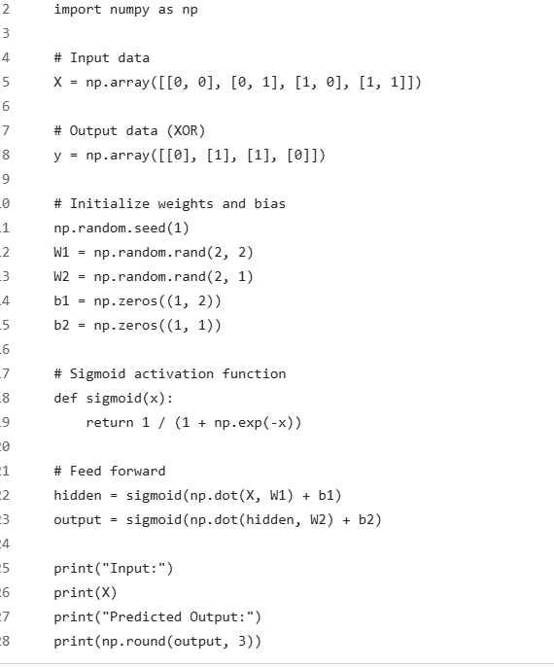
OUTPUT: 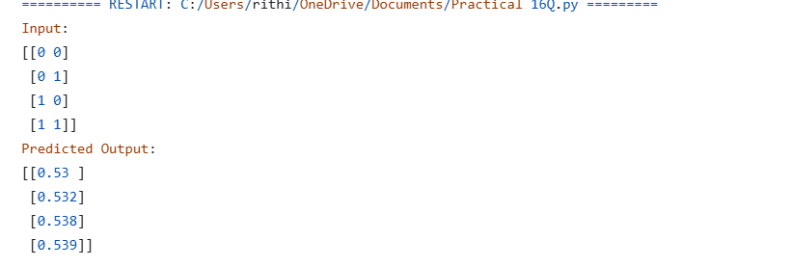
RESULT: Thus, the above program was implemented and the expected result was obtained.

PROGRAM 17: Write a Prolog program to sum the integers from 1 to n
AIM: To write a Prolog program that calculates the sum of integers from 1 to n.
PROCEDURE:
- Define a base case for n equal to zero.
- Define a recursive rule that adds n to the sum of integers from 1 to n−1.
- Save the facts and rules in a Prolog file.
- Load the file in SWI-Prolog and query the sum for a positive integer.

OUTPUT:
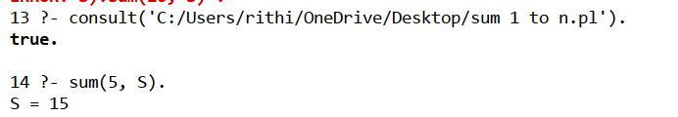
RESULT: Thus, the above program was implemented and the expected result was obtained.

PROGRAM 18: Write a Prolog program for a database with name and date of birth
AIM: To create and query a Prolog database containing names and dates of birth.
PROCEDURE:
- Define facts containing each person's name and date of birth.
- Save the facts in a Prolog source file.
- Load the file using consult/1 or the SWI-Prolog load command.
- Query the database for a particular person's date of birth or list all records.
OUTPUT:
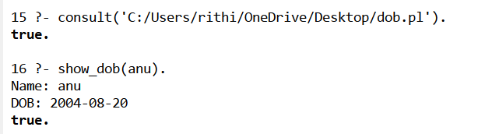
RESULT: Thus, the above program was implemented and the expected result was obtained.

PROGRAM 19: Write a Prolog program for Student-Teacher-Sub-Code
AIM: To represent and retrieve relationships among students, teachers and subject codes using Prolog facts and rules.
PROCEDURE:
- Define facts for students, teachers and subject codes.
- Create relationship facts connecting the relevant student, teacher and subject.
- Load the program into SWI-Prolog.
- Write queries to retrieve the teacher or subject associated with a student, or the students associated with a subject.
OUTPUT:
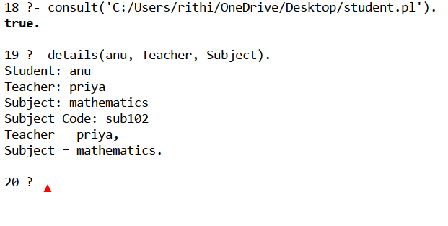
RESULT: Thus, the above program was implemented and the expected result was obtained.

PROGRAM 20: Write a Prolog program for Planets database
AIM: To create a Prolog database containing information about planets and retrieve it using queries.
PROCEDURE:
- Write facts describing planets and their properties.
- Save and load the facts in SWI-Prolog.
- Create queries to retrieve a planet's properties or list planets satisfying a condition.
- Execute the queries and observe the matching results.
OUTPUT:
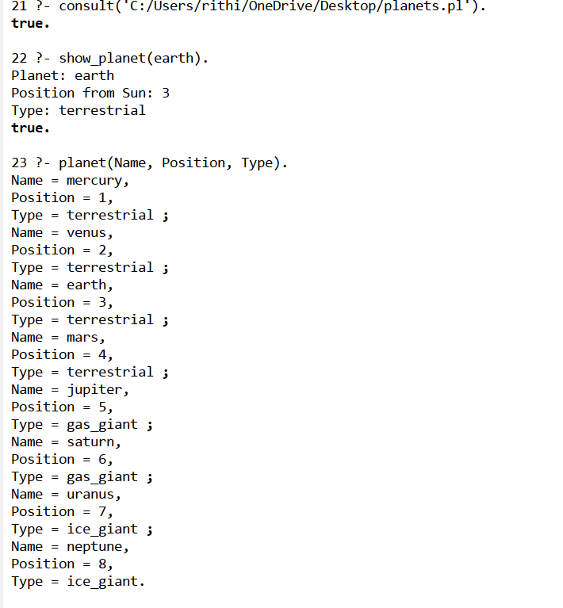
RESULT: Thus, the above program was implemented and the expected result was obtained.

PROGRAM 21: Write a Prolog program to implement Towers of Hanoi
AIM: To solve the Towers of Hanoi problem using recursion in Prolog.
PROCEDURE:
- Define the predicate hanoi/4 with the number of disks and three pegs.
- Use a base case for one disk.
- For more disks, move n−1 disks to the auxiliary peg.
- Move the largest disk to the destination peg.
- Move the n−1 disks from the auxiliary peg to the destination peg.
OUTPUT:
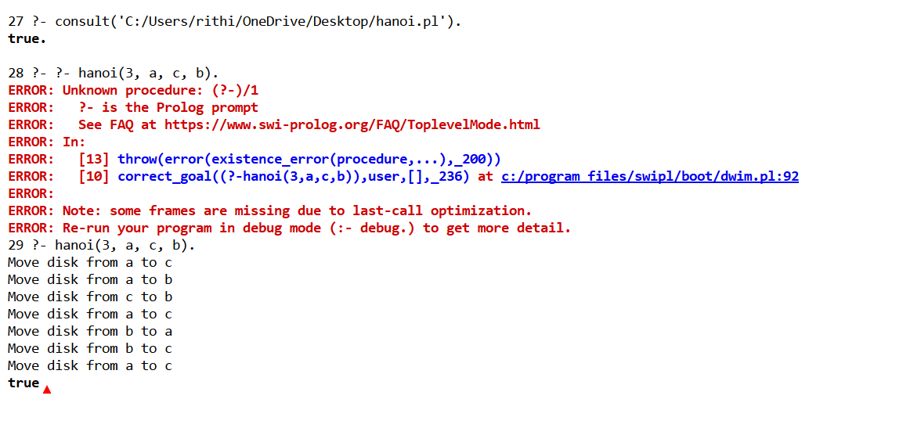
RESULT: Thus, the above program was implemented and the expected result was obtained.

PROGRAM 22: Write a Prolog program to print whether a particular bird can fly or not
AIM: To determine whether a particular bird can fly using Prolog facts and rules.
PROCEDURE:
- Define facts for birds that can fly.
- Define facts for birds that cannot fly, such as exceptions.
- Write a rule that checks whether a bird can fly while considering exceptions.
- Load the program and query different birds.
OUTPUT:
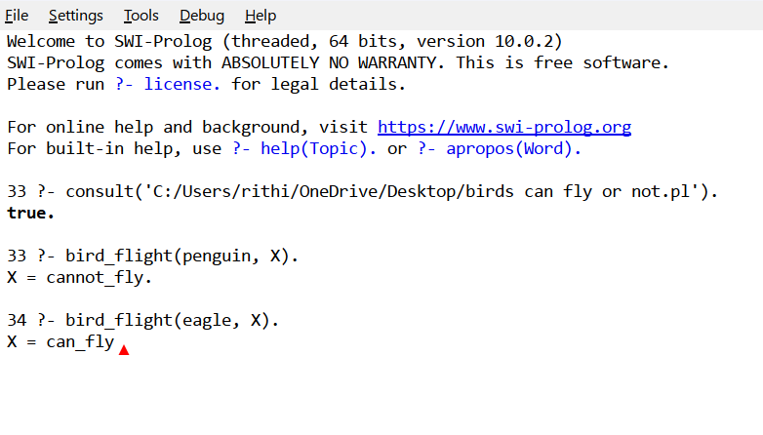

RESULT: Thus, the above program was implemented and the expected result was obtained.

PROGRAM 23: Write a Prolog program to implement Family Tree
AIM: To represent family relationships and answer relationship queries using Prolog.
PROCEDURE:
- Define facts such as parent/2 and gender-related facts if required.
- Write rules for relationships such as father, mother, sibling and grandparent.
- Load the program in SWI-Prolog.
- Execute queries to identify family relationships.
OUTPUT:
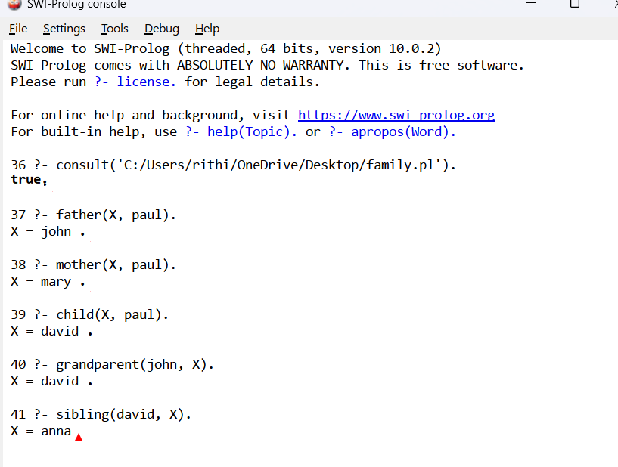
RESULT: Thus, the above program was implemented and the expected result was obtained.

PROGRAM 24: Write a Prolog program to suggest a dieting system based on disease
AIM: To create a simple rule-based Prolog program that suggests diet recommendations based on a specified disease.
PROCEDURE:
- Define disease facts and corresponding food or diet recommendation facts.
- Write rules that connect a disease with its suggested diet.
- Load the program in SWI-Prolog.
- Query the system with a disease name and display the matching suggestions.
OUTPUT:
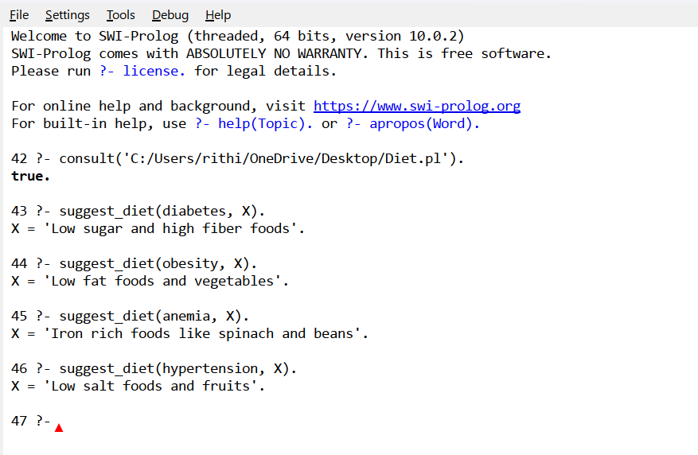
RESULT: Thus, the above program was implemented and the expected result was obtained.

PROGRAM 25: Write a Prolog program to implement Monkey Banana Problem
AIM: To represent the Monkey and Banana problem and find a sequence of actions for the monkey to obtain the banana.
PROCEDURE:
- Represent the monkey's position, box position and whether the monkey is on the box.
- Define legal actions such as walk, push, climb and grasp.
- Specify the initial state and the goal state in which the monkey has the banana.
- Use recursive state transitions or search to find a sequence of actions.
- Display the action sequence.
OUTPUT:
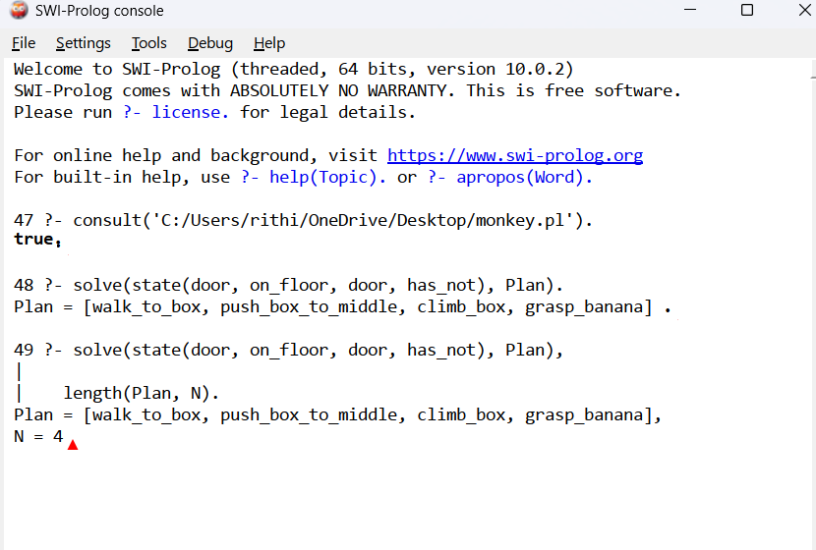
RESULT: Thus, the above program was implemented and the expected result was obtained.

PROGRAM 26: Write a Prolog program for fruit and its color using Backtracking
AIM: To store fruit-color relationships and retrieve matching fruits using Prolog backtracking.
PROCEDURE:
- Define facts that associate each fruit with its color.
- Load the facts into SWI-Prolog.
- Query fruit(Fruit, Colour) to retrieve a matching pair.
- Press the semicolon key to request further solutions through backtracking.
OUTPUT:
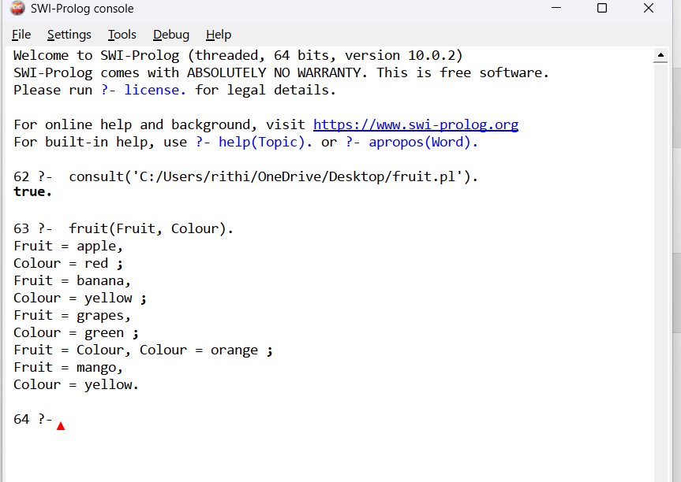

RESULT: Thus, the above program was implemented and the expected result was obtained.

PROGRAM 27: Write a Prolog program to implement Best First Search algorithm
AIM: To implement Best First Search to explore the node with the most promising heuristic value first.
PROCEDURE:
- Represent the graph and define heuristic values for nodes.
- Insert the start node into the open list.
- Select the node with the best heuristic value from the open list.
- Check whether it is the goal; otherwise add its unvisited neighbours.
- Continue until the goal is found or no nodes remain.
OUTPUT:
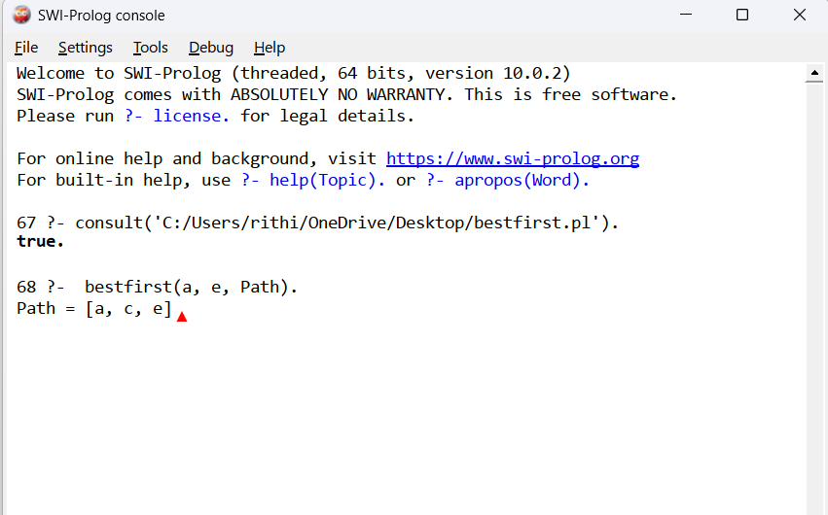
RESULT: Thus, the above program was implemented and the expected result was obtained.

PROGRAM 28: Write a Prolog program for Medical Diagnosis
AIM: To demonstrate a simple rule-based medical diagnosis system using symptoms and Prolog rules.
PROCEDURE:
- Define symptom facts or predicates for a patient.
- Write rules that associate combinations of symptoms with possible conditions.
- Load the program into SWI-Prolog.
- Query the diagnosis predicate with the patient's symptoms.
- Display the possible result based on the defined rules.
OUTPUT:
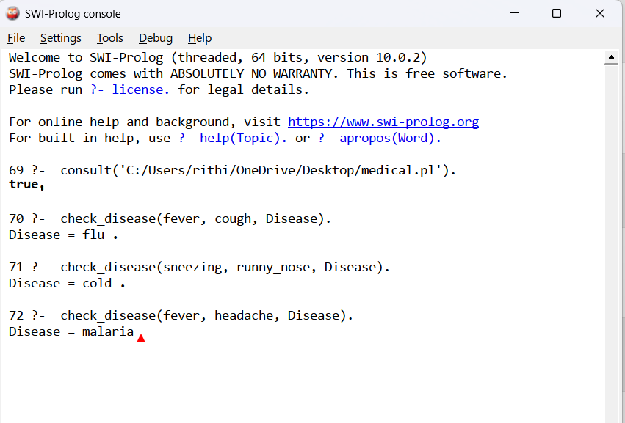
RESULT: Thus, the above program was implemented and the expected result was obtained.

PROGRAM 29: Write a Prolog program for Forward Chaining
AIM: To demonstrate forward chaining by deriving new facts from known facts and rules.
PROCEDURE:
- Enter the initial facts in the Prolog knowledge base.
- Define rules whose conditions use known facts.
- Apply rules to infer new facts from the available facts.
- Continue deriving facts until no new facts can be produced.
- Query the knowledge base for the derived conclusion.
OUTPUT:
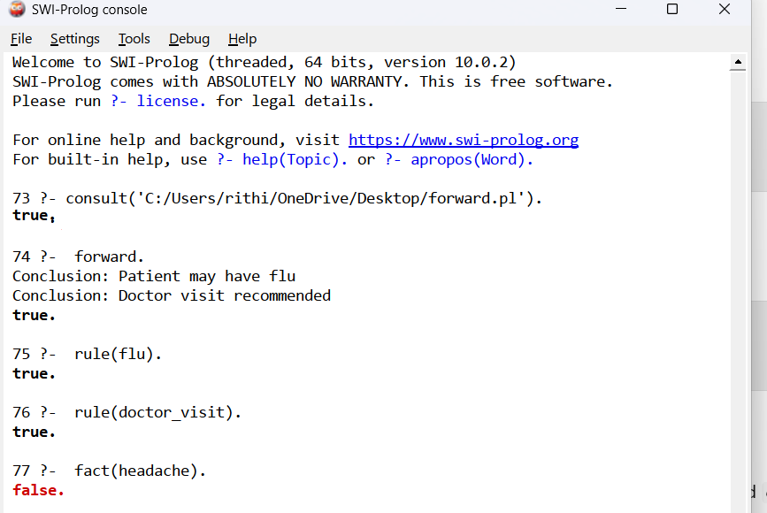
RESULT: Thus, the above program was implemented and the expected result was obtained.

PROGRAM 30: Write a Prolog program for Backward Chaining
AIM: To demonstrate backward chaining by proving a goal from rules and known facts.
PROCEDURE:
- Define facts and inference rules in the knowledge base.
- Enter a goal to be proved.
- Find a rule whose conclusion matches the goal.
- Recursively prove the conditions of that rule using facts or other rules.
- Report whether the goal succeeds or fails.
OUTPUT:
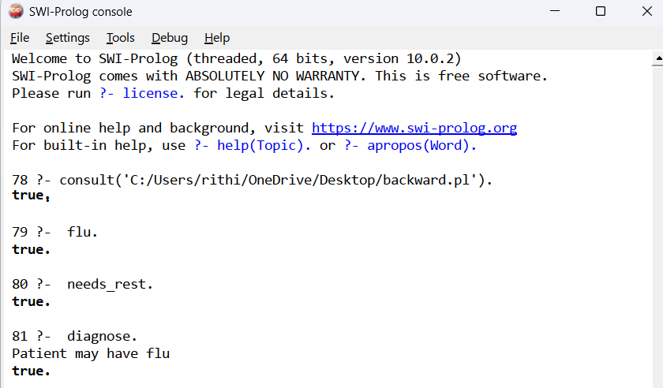
RESULT: Thus, the above program was implemented and the expected result was obtained.

PROGRAM 31: Create a Web Blog using WordPress to demonstrate Anchor Tag, Title Tag, etc.
AIM: To create a simple WordPress blog and demonstrate basic web-page elements such as anchor tags and title tags.
PROCEDURE:
- Open WordPress and create or access a website.
- Choose a theme and create a blog page or post.
- Add headings, text and links; use an anchor link to navigate to another page or section.
- Set an appropriate page or post title and demonstrate other required HTML elements using the editor or permitted custom HTML block.
- Preview and publish the blog.
OUTPUT: A WordPress blog page is created and displays the title, text and working anchor link(s).
RESULT: Thus, the above program was implemented and the expected result was obtained.

PROGRAM 32: Write a Prolog program to implement Pattern Matching
AIM: To implement pattern matching in Prolog by checking whether a given structure or term matches a specified pattern.
PROCEDURE:
- Define facts or predicates that describe the patterns to be matched.
- Write a predicate that accepts the input term and checks it against the required pattern.
- Use Prolog unification to match variables and corresponding term components.
- Load the program in SWI-Prolog and execute matching and non-matching queries.
- Observe whether each query succeeds or fails.
OUTPUT:
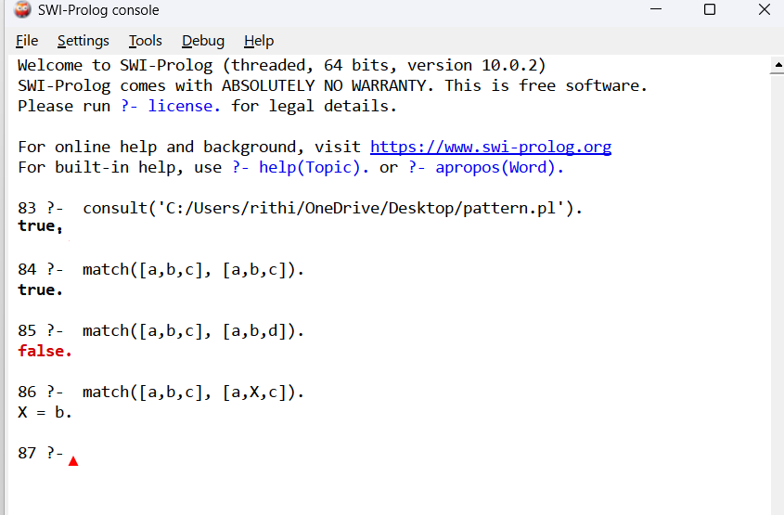
RESULT: Thus, the above program was implemented and the expected result was obtained.

PROGRAM 33: Write a Prolog program to find the number of vowels
AIM: To write a Prolog program that counts the number of vowels in a given string or list of characters.
PROCEDURE:
- Define the vowels as a list or use a predicate to recognize a vowel.
- Convert the input string into a list of characters if required by the program.
- Define a base case for an empty list with count zero.
- Use recursion to count a vowel and continue processing the remaining characters.
- Load the program and query it with an input word or string.
OUTPUT:
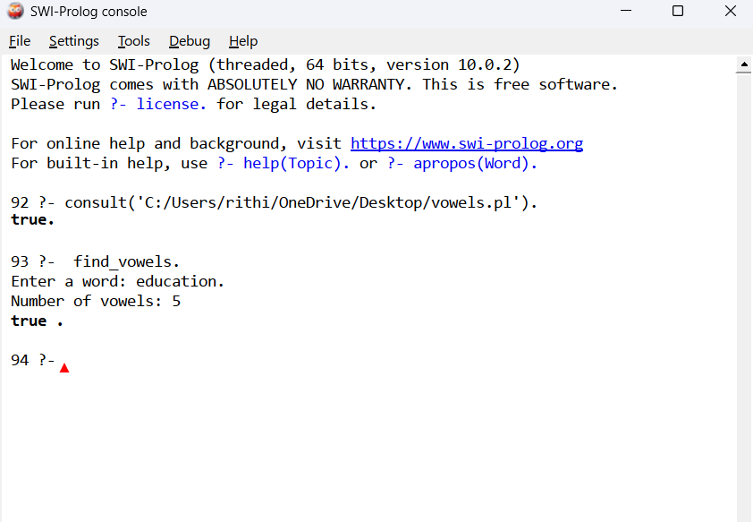
RESULT: Thus, the above program was implemented and the expected result was obtained.

